1-Web Protocols
# Source: Chatgpt (GPT-5-Mini) at [1/18/2026]
Web protocols are standardized rules and conventions that enable communication between computers on the internet, especially for accessing and interacting with websites and web services.
Here’s a breakdown:

🔹 Common Web Protocols
# Source: Chatgpt (GPT-5-Mini) at [1/18/2026]
- HTTP (Hypertext Transfer Protocol)
  - The foundation of data communication on the web.
  - Used to request and deliver web pages.
  - Example: http://example.com
- HTTPS (HTTP Secure)
  - A secure version of HTTP.
  - Encrypts the data using SSL/TLS.
  - Example: https://example.com
  - Ensures secure communication, especially for sensitive data like passwords.
- FTP (File Transfer Protocol)
  - Used to transfer files between a client and server.
  - Example use: uploading files to a website.
- SMTP (Simple Mail Transfer Protocol)
  - Used to send emails.
  - Commonly works with POP or IMAP to receive email.
- IMAP/POP (Internet Message Access Protocol / Post Office Protocol)
  - IMAP: Allows access to emails stored on a server.
  - POP: Downloads emails to a device and often deletes them from the server.
- DNS (Domain Name System)
  - Translates domain names (like google.com) into IP addresses.
- TCP/IP (Transmission Control Protocol / Internet Protocol)
  - The base protocol suite of the internet.
  - Ensures data packets are delivered across networks.
- WebSocket
  - A protocol for real-time, two-way communication between client and server.
  - Common in chat apps and live updates.

🔹 Summary
# Source: Chatgpt (GPT-5-Mini) at [1/18/2026]
Web protocols ensure that devices across the world can communicate and share information efficiently and reliably over the internet. They act like the language and rules computers use to talk to each other.

2-Web Protocols vs Internet Protocols
# Source: Chatgpt (GPT-5-Mini) at [1/18/2026]

Term | What It Means
Internet Protocols | Low-level communication rules that move data across the internet (e.g., IP, TCP, UDP)
Web Protocols | Higher-level protocols built on top of internet protocols to enable web communication (e.g., HTTP, HTTPS, FTP)

🧠 In Simple Terms:
# Source: Chatgpt (GPT-5-Mini) at [1/18/2026]
- Internet Protocols are like the postal system that routes packages (data) to the right address on the internet.
- Web Protocols are like the language and rules used to request and receive web pages or services once the data gets there.

Examples
# Source: Chatgpt (GPT-5-Mini) at [1/18/2026]

Protocol | Layer/Type | Purpose
IP (Internet Protocol) | Network layer (low level) | Routes data packets across networks
TCP (Transmission Control Protocol) | Transport layer | Ensures reliable delivery of data
HTTP (Hypertext Transfer Protocol) | Application layer (web) | Rules for web browsers and servers to communicate
HTTPS | HTTP over TLS/SSL | Secure version of HTTP

Network protocol Image
# Source: [Data Path: Miscellaneous Folder -> Miscellaneous Database -> Miscellaneous Table -> ID: 24] at [1/18/2026]
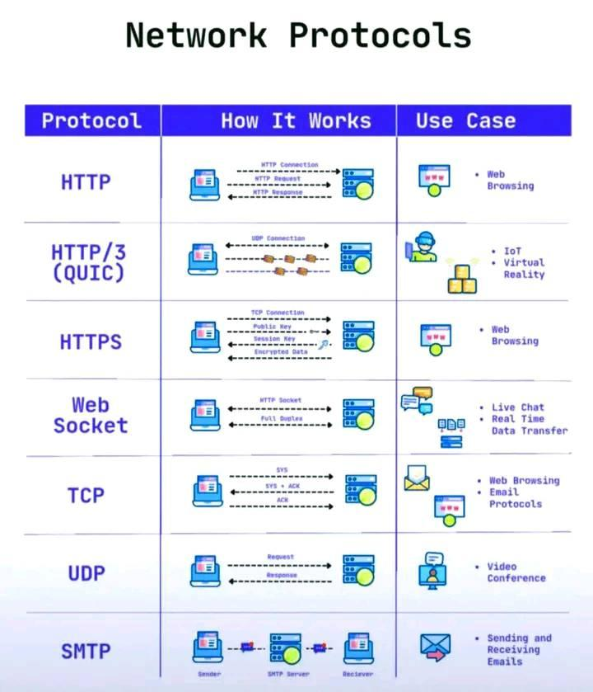

Summary
# Source: Chatgpt (GPT-5-Mini) at [1/18/2026]
Internet Protocols move data around the internet, while Web Protocols are specific rules for exchanging web content and services using those internet protocols.

